

Programming Languages Documentation for Project

Teacher: Marcin Jagiela

Students: Takunda Kadyautumbe (W66973), Kudakwashe Nyamutsaka (W67040) Brendon Nyavira (W66971)

**Table of Contents**

1. Project Description

* Introduction
* Webpage Overview
* Design and Functionality
* Code Preview

2. Conclusion

* Summary of the Project
* Reflection on Creating an Automotive Webpage

**Project Description**

Essentially our project is a webpage/web application we made during our internship with the assistance of our Supervisor. The webpage consists of a front end (presentation layer), backend (data storage layer) and database. Our webpage is a webpage that was created for car manufacturing parts. It is an automotive webpage with the purpose to find car parts for specific car models and here users can buy the car parts they require for their cars that is if the car parts are available. The page consists of a home page where sample products are shown and this can be seen in Fig.1 below. You also have a tab where you can navigate between the page and these tabs include the information about the company (about us), the products offered by the store (products) and finally how users can contact us (contact us). You can also get more information about the products as each product has the option to learn more about the product you have chosen.

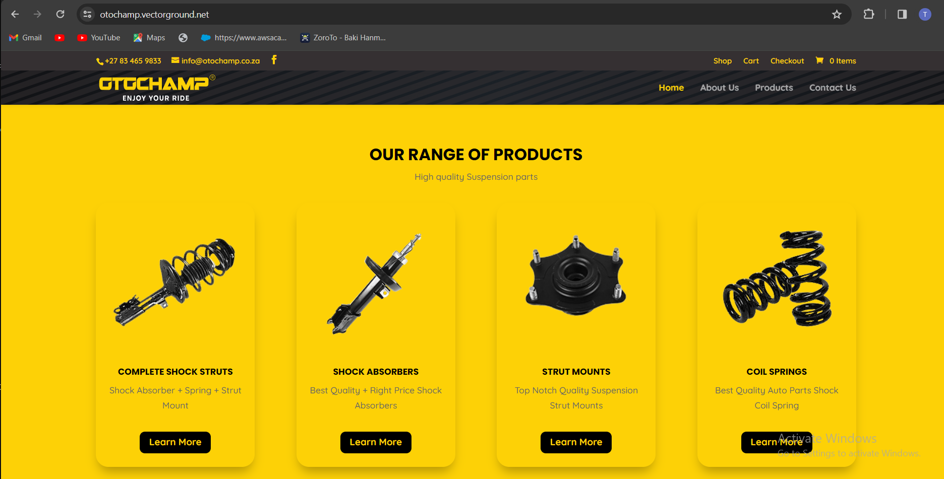

Fig.1 (own source)

The design of the project is slightly more advanced than the regular webpage however the navigation of the page is very easy and user friendly. Each button is an on click button and when you press on each button a window will open but not in a different tab thus making it easier because you can always return to the page of choice with the click of a button. As you can see in Fig.1 above the page contains images that display each item which was essential to the design of the page in order to make it appealing to a user so that the page is not a boring basic webpage. The page has multiple functionalities such as on click buttons, a search bar that will be useful for users who know what the specific shock absorber they are looking for. This was implemented to make it easier for users so they do not take a long time looking for the product they are looking for. The search bar is shown below in Fig.2, along with a search bar users can also find the model of the vehicle they are looking for. The data for these models is stored within the database that we created for the webpage. You also have the option to sort you search and there are multiple ways in which you can sort the products which include sort by popularity and average rating.

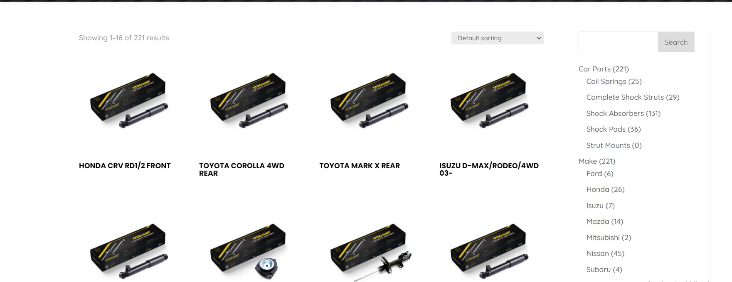

Fig.2 (own source)

We also included the option to add reviews to the products in order to improve on the products and also just to get feedback from the clients. Once the review has been submitted it will be stored in the database that has been created for the website. The review will be submitted the and upon reviewing it will either be approved or disapproved. The reason for it needing approval is so that the review is of age restriction and complies with website policies. Fig.3 below shows just how the reviewing and submission of the review works. As you can see it says your review has been submitted and is awaiting approval.

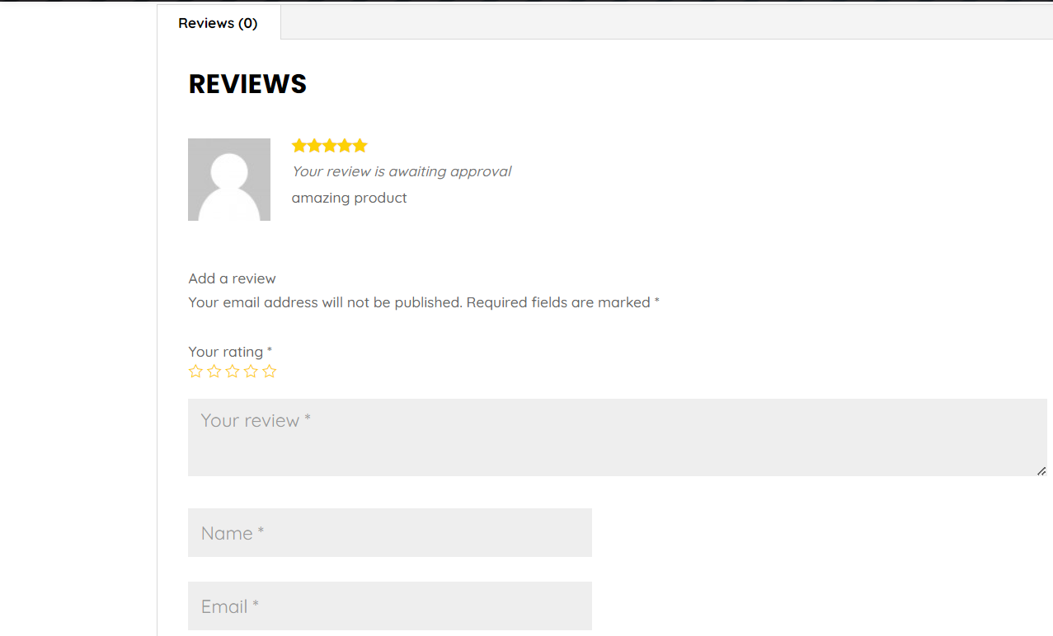

Fig.3 (own source)

Contact details have also been included in the webpage so that if there are any problems clients can always contact us for any help they need. There is also the location of the address where clients can come themselves and get the assistance they need. This is shown in Fig.4 below.



Fig.4 (own source)

**Code Preview**

In the creating of this website we used HTML, Javascript, Python, SQL and AzureDevOps.

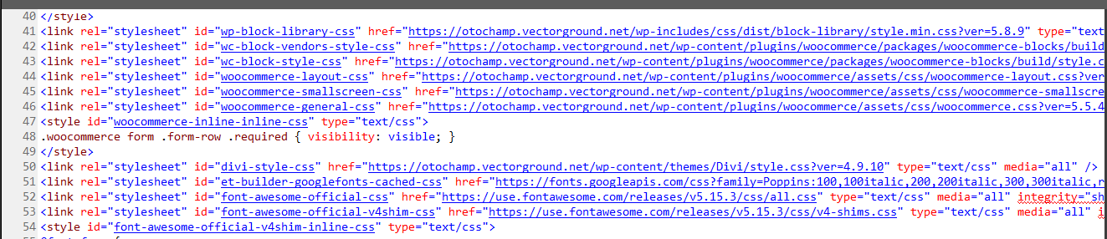

Fig.5

Fig.5 above is just a small sample of the home page showing the source code and it also showing the stylesheets that have been linked to the home page in order for the appearance of the webpage. There is also the use of plugins that we used for the creation of the webpage. Each different webpage has been linked to the home page in order for the entire webpage to open and run accordingly.

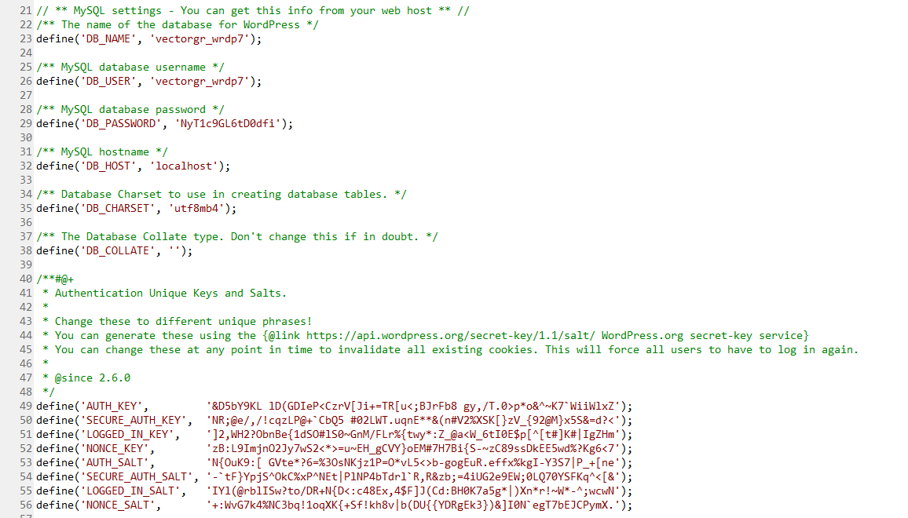

Fig.6

The figure above just shows how the database works and what its purpose is. Its got comments that tell what each command line is doing.

**Conclusion**

In conclusion the webpage took quite some time to create and with the help of our advisor we managed to create a webpage that sells and advertises car parts. Creating an automotive webpage presents an exciting opportunity to connect with car enthusiasts, owners, and professionals in the automotive industry. Through a well-designed and informative website, you can offer valuable resources, products, and services tailored to the needs and interests of your target audience .Building an automotive webpage requires careful consideration of factors such as user experience, content relevance, and functionality. By focusing on providing high-quality content, engaging features, and a user-friendly interface, you can create a compelling online destination that attracts and retains visitors. Whether it's an e-commerce platform for selling car parts, a blog sharing expert advice on vehicle maintenance, or a community forum for enthusiasts to share their passion, the possibilities are endless. With dedication, creativity, and attention to detail, you can create a successful automotive webpage that serves as a valuable resource for automotive enthusiasts worldwide.